NAME - SHRESTHA DEY
SupersetID - 7719638
DN-5.0 JavaFSE Solutions

WEEK-1 : DESIGN PATTERNS AND PRINCIPLES

Exercise 1: Implementing the Singleton Pattern
- Logger.java
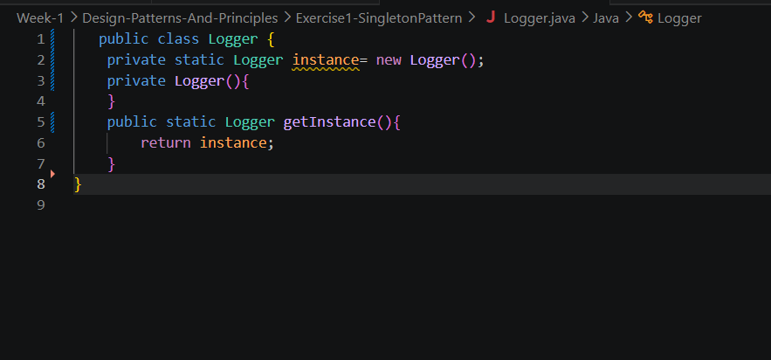
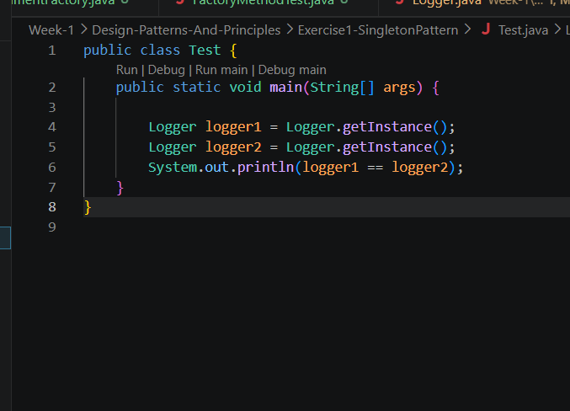
- Test.java

Exercise 2: Implementing the Factory Method Pattern

- Document.java
public abstract class Document {
public abstract void open();
public abstract void save();
public abstract void close();
}

- DocumentFactory.java
public abstract class DocumentFactory {
public abstract Document createDocument();

public void openDocument() {
Document doc = createDocument();
doc.open();
doc.save();
doc.close();
}
}

- ExcelDocument.java

public class ExcelDocument extends Document {
@Override
public void open() { System.out.println("Opening Excel Document (.xlsx)"); }
@Override
public void save() { System.out.println("Saving Excel Document"); }
@Override
public void close() { System.out.println("Closing Excel Document"); }
}

- ExcelDocumentFactory.java
public class ExcelDocumentFactory extends DocumentFactory {
@Override
public Document createDocument() { return new ExcelDocument(); }
}

- FactoryMethodTest.java

public class FactoryMethodTest {
public static void main(String[] args) {
DocumentFactory[] factories = {
new WordDocumentFactory(),
new PdfDocumentFactory(),
new ExcelDocumentFactory()
};

for (DocumentFactory factory : factories) {
factory.openDocument();
System.out.println("---");
}
}
}

- PdfDocument.java

public class FactoryMethodTest {
public static void main(String[] args) {
DocumentFactory[] factories = {
new WordDocumentFactory(),
new PdfDocumentFactory(),
new ExcelDocumentFactory()
};

for (DocumentFactory factory : factories) {
factory.openDocument();
System.out.println("---");
}
}
}

- PdfDocumentFactory.java

public class PdfDocumentFactory extends DocumentFactory {
@Override
public Document createDocument() {
return new PdfDocument();
}
}

- WordDocument.java
public class WordDocument extends Document {
@Override
public void open() { System.out.println("Opening Word Document (.docx)"); }
@Override
public void save() { System.out.println("Saving Word Document"); }
@Override
public void close() { System.out.println("Closing Word Document"); }
}

- WordDocumentFactory.java
public class WordDocumentFactory extends DocumentFactory {
@Override
public Document createDocument() { return new WordDocument(); }
}

Folder Structure:
